**Largest of Three Numbers**

Given three numbers A, B and C; The task is to find the largest number among the three.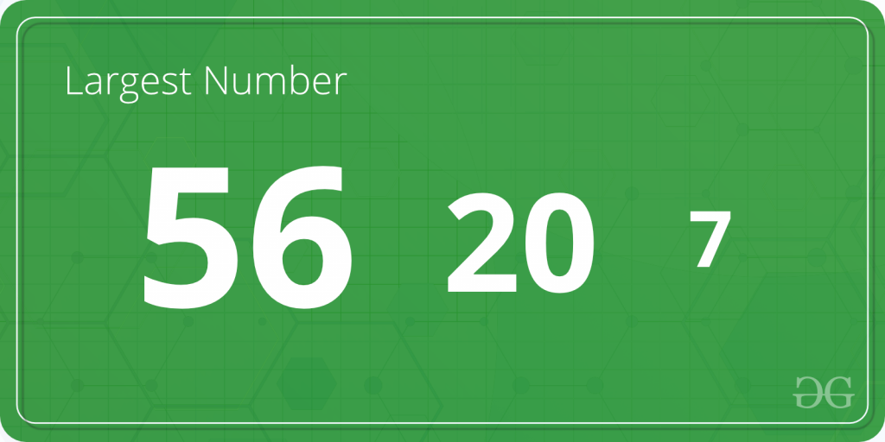

**Examples**:

***Input****: A=2, B=8, C=1*

***Output****: Largest number = 8*

***Input****:A=231,B=4751,C=75821*  
***Output****: Largest number = 75821*

C++

#include<iostream>

using namespace std;

int main()

{

int a, b, c;

cin >> a >> b >> c;

if(a>=b and a>=c)

{

cout << a;

}

else if(b>=a and b>=c)

{

cout << b;

}

else

{

cout<<c;

}

return 0;

}

**Input**

3 2 4

**Output**

4